ASTRO 445 FINAL PROJECT

FalconSAT-**9**

ATTITUDE CONTROL

25% OF COURSE GRADE

**ASSIGNMENTS: Prelim Analysis and Report LESSON 36 (Team Effort)**

**Final Design, Analysis, and Report LESSON 40 (Team Effort)**

|  |
| --- |
| **This assignment is TEAM EFFORT.  YOUR PROJECT GROUP must complete your own assignment to submit for grading.  DO NOT copy anyone else’s work or work with cadets outside YOUR PROJECT GROUP on this assignment.**    **AUTHORIZED RESOURCES:  Any current Astro 445 instructor, your own course notes, your course text. You may not receive help from cadets outside YOUR PROJECT GROUP.** |

**THIS PAGE INTENTIALLY LEFT BLANK**

1. **Objective:** Design and analyze an attitude control system for a next-generation FalconSAT.

2. **Background:** Air Force Research Laboratory (AFRL) is funding the Space Systems Research Center to design, build, test, and operate a next-generation small satellite, FalconSAT-9, to perform advanced propulsion and space maneuvering experiments. In 18 months, the spacecraft will be inserted into a 500 kilometer altitude polar orbit as a secondary payload on a Falcon 9 launch vehicle.

After deployment, the spacecraft will go through an initial check-out period to verify nominal operations of all systems. During this time, the FalconSAT-9 will be tumbling due to the initial angular rates generated during launch vehicle separation as well as the influence of environmental disturbance torques. Upon establishment of normal operations, the first attitude control objective will be to detumble and orient the spacecraft with respect to a local vertical/local horizontal (LVLH) orbit reference frame

The primary mission of FalconSAT-9 is to test an advanced Hall-effect thruster developed by AFRL’s Space Propulsion Directorate. During thruster firings, the spacecraft must be able to maintain an orbit-fixed orientation as well as perform slew maneuvers to point the thruster in a desired direction. Despite the best effort of technicians to align the propulsions system’s thrust vector with the spacecraft’s center of mass, a small misalignment results in a constant disturbance torque during firings. The satellite also has an external payload attached opposite of the Hall-effect thruster.

3. **System Specification:**

1. **Reference Frames**

CAD Body-Fixed Frame

Mechanical designers have generated a high-fidelity computer aided design (CAD) model of FalconSAT-9, shown in Figure 1. The model identifies the orientation and location of components using a body-fixed reference frame centered at the middle of the cylindrical launch vehicle adapter ring. The ${\hat{b}}_{1}$ and ${\hat{b}}_{2}$ vectors lie in the launch vehicle interface plane, with ${\hat{b}}_{1}$ normal to the +X body panel housing the plasma instruments and ${\hat{b}}_{2}$ normal to the +Y body panel. The ${\hat{b}}_{3}$ vector is defined using the right-hand rule, normal to +Z panel containing the Hall-effect thruster.

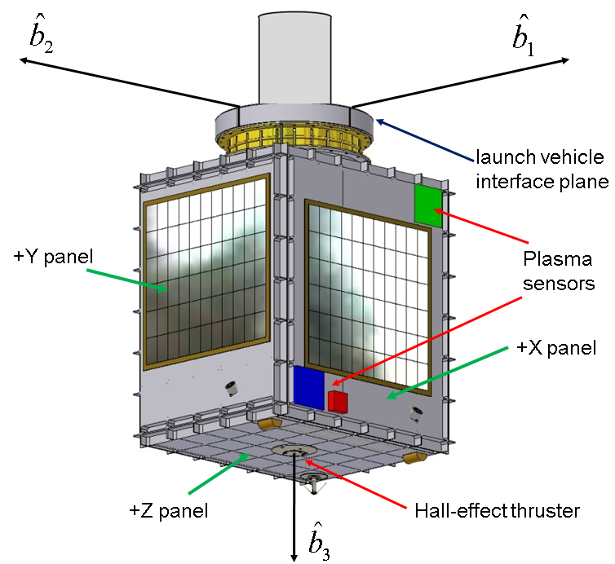

Figure 1: FalconSAT-9 Configuration

Inertial and LVLH Orbit-Fixed Frames

The spacecraft’s orientation in three-dimensional space may be defined in terms of an inertial or an orbital reference frame (see Figure 2).

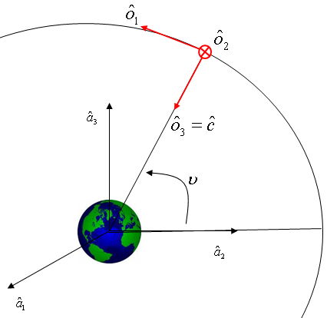

Figure 2: LVLH Orbit-Fixed Frame

The inertial frame is a standard Geocentric Equatorial reference system. The orbital frame is a local vertical/local horizontal (LVLH) system, with its origin at the spacecraft’s center of mass and a set of unit vectors aligned such that ${\hat{o}}_{1}$ is pointing in the direction of the spacecraft’s velocity vector, ${\hat{o}}_{2}$ is perpendicular to the orbital plan, and ${\hat{o}}_{3}$ is pointing toward the center of the Earth.

1. **Mass Properties**

The mechanical team has defined the mass properties of the spacecraft in terms of two major assemblies: the primary spacecraft assembly and the external payload.

Spacecraft Assembly

The spacecraft assembly includes all FalconSAT-9 structure, subsystems, and components other than the payload. Its mass is:

$$m_{S/C}=148.5kg$$

The spacecraft assembly inertia matrix is defined **with respect to the assembly’s center of mass**, in terms of components in the CAD body-fixed frame.

$$I_{S/C}≡{\left[\begin{aligned}&\text{ 16.20 -0.40 -0.40} \\ &\text{ -0.40 13.30 -0.40} \\ &\text{ -0.40 -0.40 6.40}\end{aligned}\right]}_{B}kg⋅m^{2}$$

The spacecraft assembly center of mass is defined from the origin of the CAD frame:

$$[r_{S/C_R}]_{B}=\left[\begin{matrix}-0.01 \\ 0.01 \\ 0.37\end{matrix}\right]m$$

Payload Assembly

The payload’s mass is:

$$m_{PL}=10.5kg$$

The payload assembly inertia matrix is defined **with respect to the payload assembly’s center of mass**, in terms of components in the CAD body-fixed frame

$$I_{PL}≡{\left[\begin{aligned}&\text{ 0.10 0.00 0.00} \\ &\text{ 0.00 0.10 0.00} \\ &\text{ 0.00 0.00 0.05}\end{aligned}\right]}_{B}kg⋅m^{2}$$

Defined from the origin of the CAD frame the center of mass location is:

$$[r_{Payload}]_{B}=\left[\begin{matrix}0.00 \\ 0.00 \\ -0.05\end{matrix}\right]m$$

1. **ADCS Hardware**

To meet attitude knowledge requirements, FalconSAT-9 is equipped with a suite of sensors (specifications in Appendix A). These include four sun sensors, a star tracker, a three-axis magnetometer, and three quartz rate sensors. The flight processor integrates the data from these sensors into a Kalman filter that provides low-noise estimates of the orientation of the body with respect to the LVLH frame.

To maximize performance and operational flexibility, designers have given FalconSAT-9 multiple means of generating attitude control torques (specifications in Appendix B). Three reaction wheels aligned with the spacecraft’s principle frame capable of providing 3-axis active control. Three pairs of cold gas ADCS micro-thrusters provide roll-pitch-yaw control torques for detumble, gross attitude control, and reaction wheel momentum dumping.

1. **ADCS Modes:**

The Concept of Operations (CONOPS) for FalconSAT-9 calls for two distinct control modes corresponding to two major mission phases.

Mission Phase/Control Mode 0: Deployment and Detumble:

After launch, USAFA ground station operators will establish communications with FalconSAT-9 and execute initial systems checkout. During the first two weeks, the attitude control system will be inactive, leaving the spacecraft to tumble as a result of its initial angular rates at launch vehicle separation (tip-off) and subsequent environmental disturbance torques. Following system checkout, Control Mode 0 will be activated using the micro-thrusters in an on-off (bang-bang) mode to detumble the spacecraft and achieve an initial mission orientation.

Mission Phase/Control Mode 1: Electric Propulsion Experiments:

With deployment and detumble complete, FalconSAT-9 enters Mission Phase 1 in which ground operators conduct a series of firings of the experimental Hall-effect propulsion system. During this six-month period, the ADCS system operates in Control Mode 1. The reaction wheels provide disturbance rejection and active control of pointing and slewing maneuvers to orient the thrust vector of the propulsion system during firings. In Control Mode 1, the micro-thrusters provide momentum dumping for the reaction wheel.

1. **Disturbances:**

Both self-induced and environmental disturbances will impact the ability of FalconSAT-9 to maintain a desired orientation. Environmental disturbances include atmospheric drag, magnetic torque, gravity gradient, and solar pressure. Atmospheric drag and magnetic torques are both cyclic and of roughly the same magnitude, so only one will be modeled for control design. Gravity gradient torque will be modeled directly in the equations of motion while solar pressure on the small satellite is small enough with respect to other disturbances to be ignored.

Thruster Misalignment

The experimental Hall-effect thruster is slightly misaligned such that thruster force does not go directly through the spacecraft center of mass. The resulting disturbance can be modeled as a constant torque of 25 × 10-6 *Nm* in both pitch and roll axes. The maximum planned thruster firing duration is 300 seconds.

Magnetic Torque

Assuming the spacecraft has a non-zero magnetic moment, ${\overline{m}}_{m}$, its interaction with the magnetic flux density, $\overline{B}$, of the Earth’s magnetic field can be modeled as a cyclic torque:

$${\overline{g}}_{m}={\overline{m}}_{m}×\overline{B}$$

For FalconSAT-9, the magnitude of this disturbance torque is modeled as:

$$\left|{\overline{g}}_{m}\right|≅2.0×{10}^{-6}\sin\left(2ω_{c}t\right)Nm$$

where $ω_{c}$ is the orbital mean motion.

**4. Preliminary Analysis (35% of Final Project Grade):**

Present your results neatly, hand written or in a Matlab Live script. This will be an appendix for your final project.You will later need to discuss these results and mathematical theory in your final report.

1. **Mass Properties**

Calculate the following:

1. Location of the total spacecraft center of mass from the origin of the CAD frame.
2. Total body-fixed inertia matrix defined **with respect to the total spacecraft center of mass**, in terms of components in the CAD body-fixed frame.
3. Directional cosine matrix (DCM), $C_{P/B}$, that defines the principle reference frame, $F_{P}$, that most closely coincides with the unit vectors in the CAD body-fixed frame
4. Total inertia matrix in the above principle frame
5. **Equations of Motion**

Complete the following:

**Control Mode 1**

1. Starting with the nonlinear equations of motion between the body (do not assume a principle frame) and the orbital frame (LVLH) including the reaction wheels and gravity gradient torque,

$\frac{d}{dt}\left[\begin{matrix}\overline{ω} \\ q_{0} \\ q \\ {\overline{h}}_{w}\end{matrix}\right]=\left[\begin{matrix}{I_{T}}^{-1}\left[-I_{T}\left(-{\overline{ω}}^{×}Q_{P/O}+Q_{P/O}{{\overline{ω}}_{c}}^{×}\right){\overline{ω}}_{c}-(\overline{ω}-ω_{c}Q_{2})×{(I}_{T}(\overline{ω}-ω_{c}Q_{2})+{\overline{h}}_{w})+g_{c}+3ω_{c}^{2}Q_{3}×I_{T}Q_{3}\right] \\ -\frac{1}{2}{\overline{ω}}^{T} q \\ -\frac{1}{2}{\overline{ω}}^{×}q+\frac{1}{2}q_{0}\overline{ω} \\ -g_{c}\end{matrix}\right]$

derive the linearized equations of motion in state space form about $\overline{ω}=0, q_{0}=1, q=0, {\dot{q}}_{0}=0, h=h_{nom}$ 
 .

Provide the state space matrices **A**, **B**, **C**, and **D**. Represent equations first in general form, then substitute the numerical values you found for mass properties, mean motion, and nominal reaction wheel angular momentum.

Include torques due to gravity gradient and the reaction wheels. Identify **all** assumptions made at each step of the derivation. When appropriate, comment on the reasonableness of assumptions.

1. Draw a block diagram for the satellite model including the spacecraft plant, the (yet-to-be-designed) controller, and reaction wheel actuators. Include and label all appropriate signals, branches, and blocks that will be needed to implement the block diagram into Simulink for this project. (A skeleton Simulink model will be provided after the Prelim has been turned in.)
2. Comment on the implications for how the reaction wheels should be operated and recommend a nominal wheel speed for each reaction wheel.

**Control Mode 0**

1. Calculate the satellite’s pitch libration frequency (in rad/s) and periods (in minutes).
2. Generate a phase plane plot of ${\dot{θ}}_{2}$ vs. $θ_{2}$ (in deg and deg/s) assuming no external torque. For $θ_{2}=0$ find the pitch rate ${\dot{θ}}_{2}$ (in deg/s) at which motion transitions from an oscillation about the equilibrium to tumbling.

**5. Final Design, Analysis, and Report (65% of Final Project Grade):**

Present your results in a **Full Length Report** conforming to Department of Astronautics Technical Report Writing Guide format (On Teams). Include the results of preliminary analysis in the final report (this should also be discussed in the math technique of the written portion of your report).

1. **Control Mode 0**

Control Mode 0 uses micro-thrusters in an on-off (bang-bang) mode to detumble the spacecraft and achieve an initial mission orientation. There are six thrusters in three pairs of two, each located 0.5 meters from the stowed center of mass. Assume actuator dynamics induce a 0.1 second delay in thruster response.

1. Use phase plane and describing function techniques to design a nonlinear pitch axis control law using the micro-thrusters in a relay (on-off) mode to detumble the spacecraft. Determine proportional plus derivative feedback gains to recover from an initial pitch angular velocity ( ${\dot{θ}}_{2})$ of at least four times value found to produce tumbling motion with an initial condition of $θ_{2}=0$. Control Mode 0 should achieve and stay within 2 degrees of final orientation within 90 minutes of activation. Select an appropriate deadband width to eliminate limit cycling behavior.
2. Include a block diagram of your control law showing the selected gains and deadband.
3. Include and discuss the following plots for the 90 minutes of Control Mode 0:

a) Phase plane plots of ${\dot{θ}}_{2}$ vs. $θ_{2}$. One plot should show the entire phase plane, and one should zoom in on the final portion of the switching line.

b) Response plots showing $θ_{2}$ as a function of time.

c) Micro-thruster firings versus time.

- Calculate the total amount of time micro-thrusters are operational. (An **extra 5 points** will be awarded to the team that meets all Mode 0 requirements with the least amount of thruster on time.)

1. Implement your design in MATLAB/SIMULINK. Include a diagram of your SIMULINK model and associated M-files.
2. **Control Mode 1**
3. Develop a reaction wheel control law to meet the following requirements:

For a commanded input in all directions:

* The satellite shall be able to slew $±{45}^{°}$ off nader in 600 seconds (from $+{45}^{°}$ to $-{45}^{°}$ in both roll and pitch)
* The satellite shall be able to track commanded angles with steady-state error less than 1%.

1. Validate your linear reaction wheel controller design using the provided nonlinear satellite dynamics model. Include appropriate analysis and plots of the quaternion and Euler angle response, commanded wheel torques, and resulting wheel angular velocities, and selected feedback control gains. Ensure your control law does not saturate the wheel’s physical constraints listed on the last page (max torque and max speed). For the disturbance rejection in b and c below, verify the pitch angle error does not exceed 0.15 degrees throughout the simulation. Accomplish by running the following cases:
   1. Response to a 90 degree roll slew ( $+{45}^{°}$ to $-{45}^{°}$) in (no thruster misalignment or magnetic torques). Produce the following plots:
      1. Euler angles (deg) vs time (min) for 12 minutes
      2. gs (Nm) vs time (min) for all reaction wheels for 12 minutes
      3. ωs (RPM) vs time (min) for all reaction wheels for 12 minutes
   2. Response to a 90 degree pitch slew ( $+{45}^{°}$ to $-{45}^{°}$) in (no thruster misalignment or magnetic torques). Produce the following plots:
      1. Euler angles (deg) vs time (min) for 12 minutes
      2. gs (Nm) vs time (min) for all reaction wheels for 12 minutes
      3. ωs (RPM) vs time (min) for all reaction wheels for 12 minutes
   3. Response to a 300 second thruster misalignment torque (0 degree step input and no magnetic torque). Produce the following plots:
      1. Euler angles (deg) vs time (min) for 12 minutes
      2. gs (Nm) vs time (min) for all reaction wheels for 12 minutes
      3. ωs (RPM) vs time (min) for all reaction wheels for 12 minutes
   4. Response to a magnetic torque (0 degree step input and no thruster misalignment torque). Produce the following plots:
      1. Euler angles (deg) vs time (min) for 100 minutes
      2. gs (Nm) vs time (min) for all reaction wheels for 100 minutes
      3. ωs (RPM) vs time (min) for all reaction wheels for 100 minutes
2. Implement your design in MATLAB/SIMULINK. Include a diagram of your SIMULINK model and associated M-files. Comment on any differences between your linear analysis and the nonlinear simulation. Based on your analysis, are there any recommended changes you would suggest to the FalconSAT-9 design team (think about roll/pitch/yaw stability)? Develop and talk about a concept to maintain wheel spin rate within the necessary limit (no need to incorporate it into your SIMULINK model).

APPENDIX A

FALCONSAT-9 ATTITUDE SENSORS

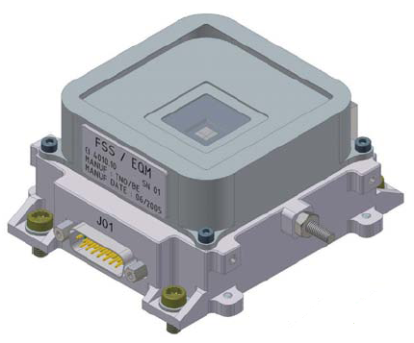 **[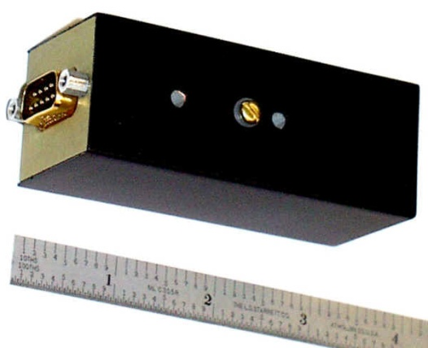](http://www.magnetometer.com/g2.jpg)**  
3 Bradford Sun Sensors Billingsley 3-Axis Magnetometer  
+/- 0.1 deg accuracy +/- 2.0 deg accuracy

Systron Donner Quartz Rate Sensor Blue Canyon Technologies  
 +/- 1 arcsec accuracy

APPENDIX B

FALCONSAT-9 ATTITUDE CONTROL ACTUATORS

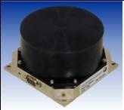 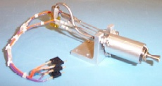

MicroWheel 1000 Reaction Wheel Cold Gas Micro-thrusters

Inertia of rotor: 0.0021 kgm2 On/off operations

Max wheel torque: 0.025 Nm Thrust for a pair of thrusters: 0.0002 N

Max wheel Speed: +/- 6500 rpm